Task 1:Write an SQL query to print the FIRST_NAME from Worker table after removing white spaces from the right side.

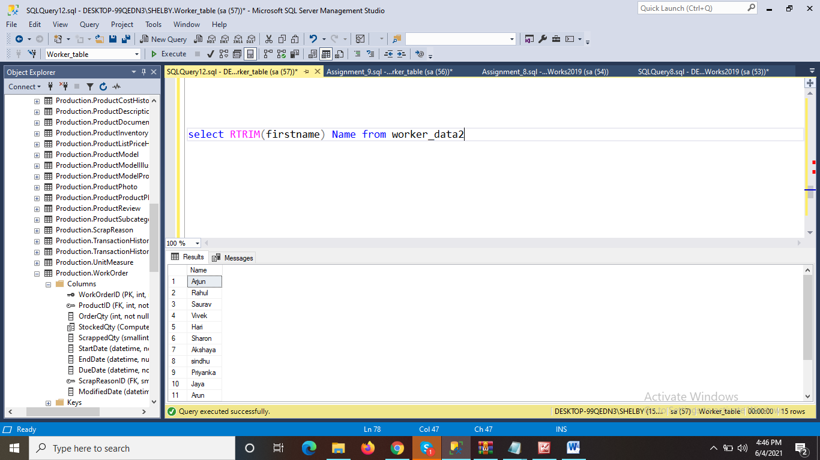

Task 2: Write an SQL query that fetches the unique values of DEPARTMENT from Worker table and prints its length

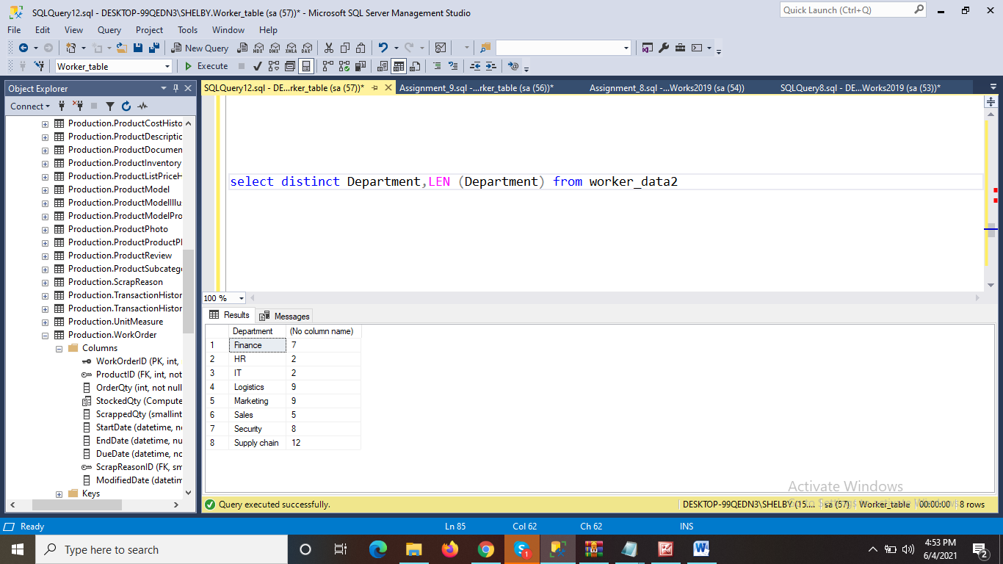

Task 3:

Write an SQL query to fetch nth max salaries from a table.

